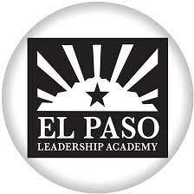
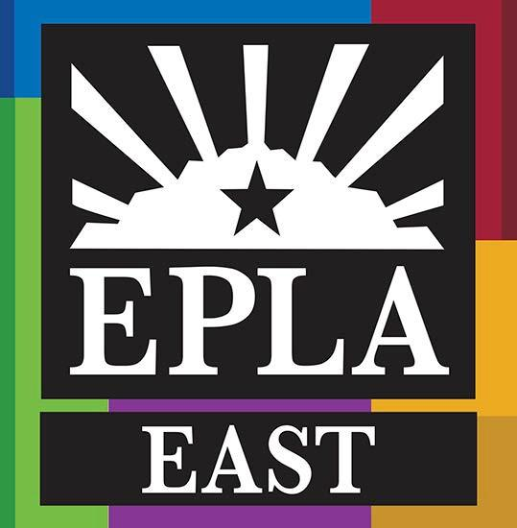
El Paso Leadership Academy
We Build, We Lead, We Make Change

Child Nutrition
CIVIL RIGHTS COMPLAINT PROCEDURES

El Paso Leadership Academy provides the Child Nutrition Program assistance to all eligible individuals without discrimination on the bases of race, color, national origin, sex, age, or disability.
If you feel in any way that your child has been discriminated against while participating in the Child Nutrition Program, including during the serving of meals to him/her, please follow these procedures in voicing your complaint:
- Please fill out the Discrimination Complaint Form at El Paso Leadership Academy
Main Office, at 5919 Brook Hollow, El Paso, TX 79925.
- Present your form to the Child Nutrition Director, Miriam Martinez (915-271-8979) or take the form to your child’s principal.
All written complaints will be accepted by the school district and forwarded to the Food and Nutrition Division, Texas Department of Agriculture.
- If you wish to file a Civil Rights Program complaint of discrimination, complete
the USDA Program Discrimination Complaint Form, found online at http://www.ascr.usda.gov/complaint_filing_cust.html, or at any USDA office, or call (866) 632-9992 to request the form. You may also write a letter containing all of the information requested in the form. Send your completed complaint form or letter to them by mail at:
U.S. Department of Agriculture
Office of the Assistant Secretary for Civil Rights
1400 Independence Avenue, S.W.
Washington, D.C. 20250-9410
by fax: (202) 690-7442 or email at program.intake@usda.gov

Individuals who are deaf, hard of hearing or have speech disabilities may contact USDA through the Federal Relay Service at (800) 877-8339; or (800) 845-6136 (Spanish). USDA is an equal opportunity provider and employer.

Non-Discrimination Statement: In accordance with Federal civil rights law and U.S. Department of
Agriculture (USDA) civil rights regulations and policies, the USDA, its Agencies, offices, and employees, and institutions participating in or administering USDA programs are prohibited from discriminating based on race, color, national origin, sex, disability, age, or reprisal or retaliation for prior civil rights activity in any program or activity conducted or funded by USDA. Persons with disabilities who require alternative means of communication for program information (e.g., Braille, large print, audiotape, American Sign Language, etc.), should contact the Agency (State or local) where they applied for benefits. Individuals who are deaf, hard of hearing or have speech disabilities may contact USDA through the Federal Relay Service at (800) 877-8339. Additionally, program information may be made available in languages other than English.

